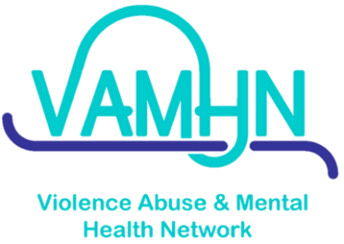
Survivor/Lived Experience Advisory Group Application Form
(Any information provided during the application process is confidential and will not be shared outside the network team)
Thank you so much for your interest in applying to the Lived Experience Advisory Group
The application period closes midnight on Sunday 14th June 2020. We will then draw up a shortlist and invite selected applicants for an informal telephone discussion, which would be scheduled in early July 2020.
Before completing this form, we encourage you to read the detailed description of the role, which can be found here:
Please send in the completed form (and your CV, if you wish to share it with us) to the Survivor/Lived Experience Coordinator (Sara) via email to vamhn@kcl.ac.uk and do get in touch if you have any questions.
Full Name

Email Address

Contact Number

First part of postcode
Do you have any requirements you would like us to be aware of in order to make our meetings more accessible?
About You
Please tell us why you would like to join this group?

What do you hope you might gain from being a member of this group?

Please use the space below and on the next page if you’d like to include any other information that you think might be helpful for us to know about why you might be suitable for this role (such as any relevant voluntary or professional activities). We are not asking you to disclose your personal lived experiences of violence, abuse or mental health issues.

Optional:
We would welcome receiving your CV via email along with this application form, but only if you wish to send it to us.

