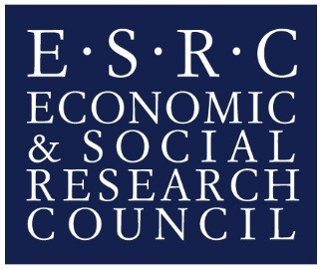
Early Career Researcher Training Bursary Application Form
Please email your completed application form with any supporting documents to vamhn@kcl.ac.uk with the email header “YOUR NAME_ ECR Bursary Application Form”
Applications accepted from 25th May 2022
Submission deadline: 4th November 2022, 5pm

About the VAMHN Early Career Researcher Training Bursary Scheme
The VAMHN Early Career Researcher Bursary supports junior researchers to attend training courses, research placements at institutions other than their own, and conferences. Bursaries can be used towards training course and/or conference fees, or for travel and accommodation to support attendance. Funds cannot be used for research costs, or to purchase books, software, licenses, or equipment.
The VAMHN runs two funding calls for the bursary each year from 2019 until 2022. Applicants are assessed on their funding needs as well as their case for support.
The maximum bursary value is £350.

Eligibility
To proceed with your application, you must meet the following eligibility criteria:
- You must be a member of the Violence, Abuse and Mental Health Network
(To join the network sign up to the newsletter here).
- You must be either:
  - A PhD Student or Early Career Researcher at a UK higher education institute (HEI);
  - An independent (i.e. not affiliated to a university or organisation) researcher based in the UK;
  - A person who has worked for a charity or public sector organisation in a role that includes a significant research component for up to eight years.
- Your application must focus on domestic/sexual violence and mental health.
- Your application should demonstrate how the funded activity would support future interdisciplinary practice.
- If your application is successful, you must agree to write a summary of approximately 200 words on the event related to this claim that will feature on our website.

Applicant Details
Title
First Name(s)
Last Name
Organisation
Position at Organisation
Email
Twitter handle
Name of requested conference/training/placement etc.
Dates of requested conference/training/placement etc.

Case for Support
(Please take max. 300 words to explain what this money will be used for and why it would be helpful or is essential for your research)

Details of Financial Request
(Please provide a breakdown of your financial request)
NB: The maximum amount that can be claimed is £350. The bursary will be administered via the King’s expenses system meaning successful applicant will book and pay for their own arrangements as stated in the financial request and provide receipts to then be reimbursed. Please note that King’s can only reimburse 3* accommodation and standard/economy class travel.

Support documentation
(Please attach any additional documentation or details that are required for your claim e.g., conference website, attendance dates, registration fees, details of your current funding status etc.)

Signed ………………………………………………………………. Date………………………………………………

The VAMHN uses the AHRC’s formal definition of an ECR: an individual who is within eight years of the award of their PhD or equivalent professional training, or an individual who is within six years of their first academic appointment. These durations exclude any period of career break, e.g. for family care or health reasons.
The VAMHN defines interdisciplinary practice as the integration of separate disciplinary methods, concepts and theories, in order to create new disciplinary insight.

